May
Theme: Growth
Purpose: To celebrate how far you have come on this journey with equity, and to acknowledge that growth is always possible.
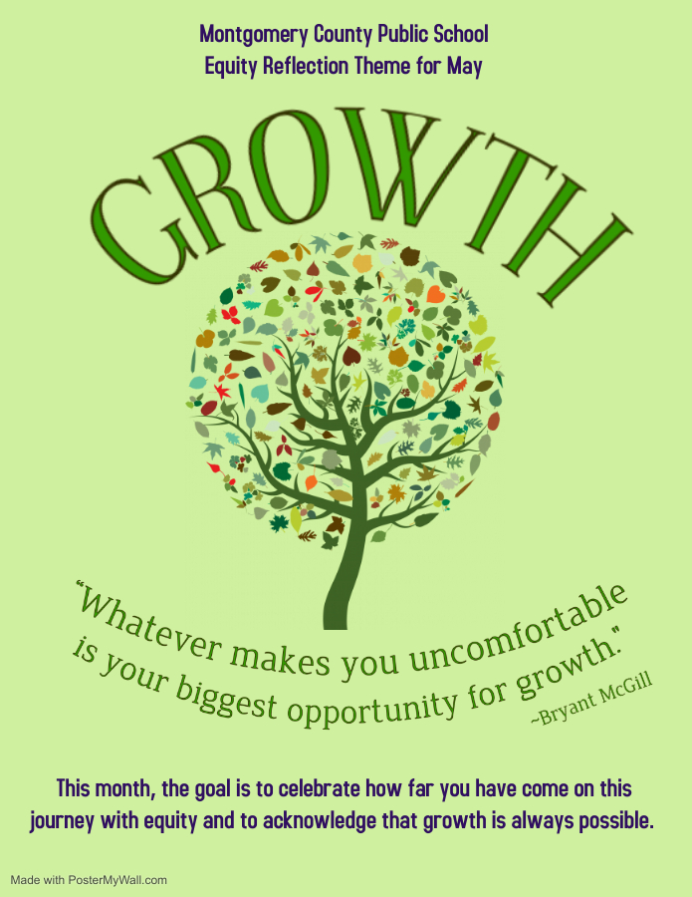
Reflection Link: Growth Ideas

April
Theme: Reflection
Purpose: To take time to reflect on your experiences and interactions in order for us to better understand ourselves and those around us.
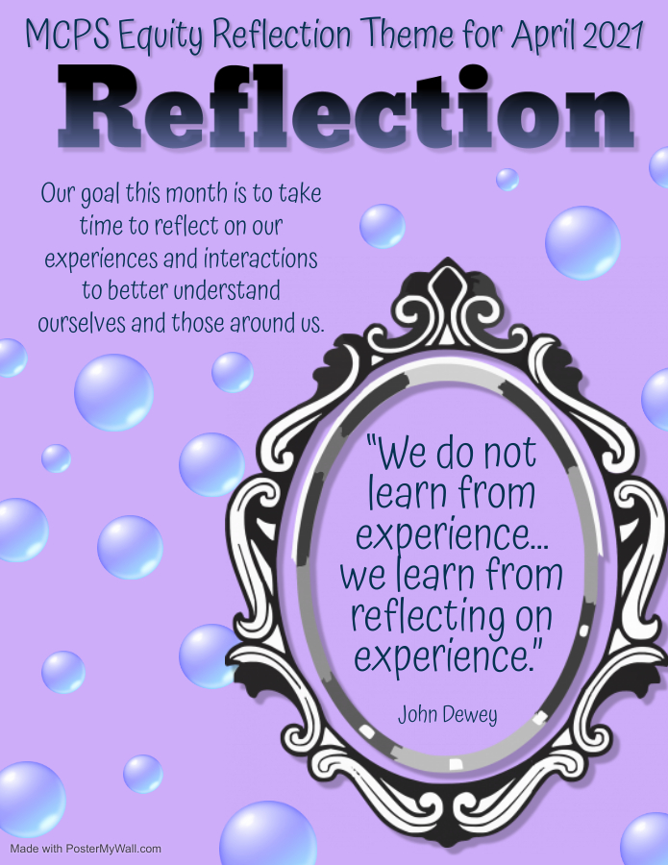
Resource Link: Self-reflection

March
Theme: Bias
Purpose: To acknowledge that bias exists in many aspects of everyday life. Understand that we must disrupt it when we see it.
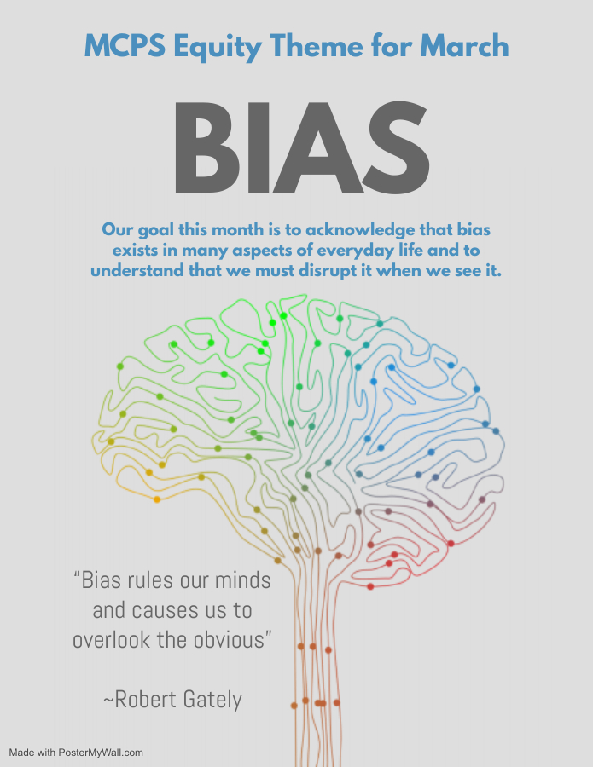
Resources Link: Resist bias

February
Theme: Diversity
Purpose: To acknowledge diversity as a strength and use it to improve understanding, social skills, and academics.
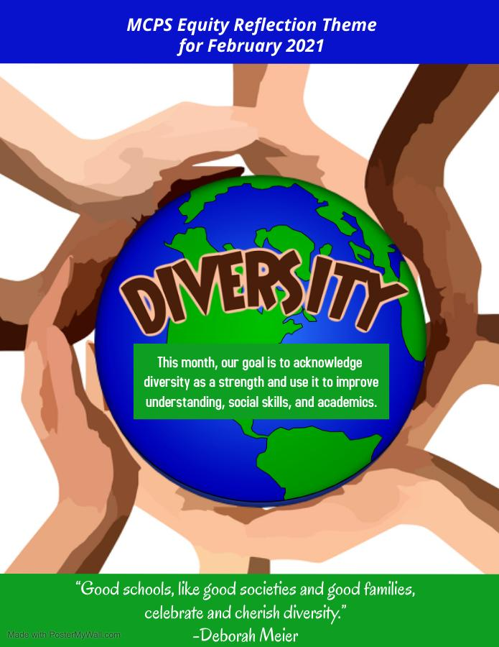
Resource Link: Diversity at Home

January
Theme: Capacity
Purpose: To improve the skill and ability of educators to recognize bias and inequity in our systems and practices. Use this capacity to ensure all students receive an equitable education.
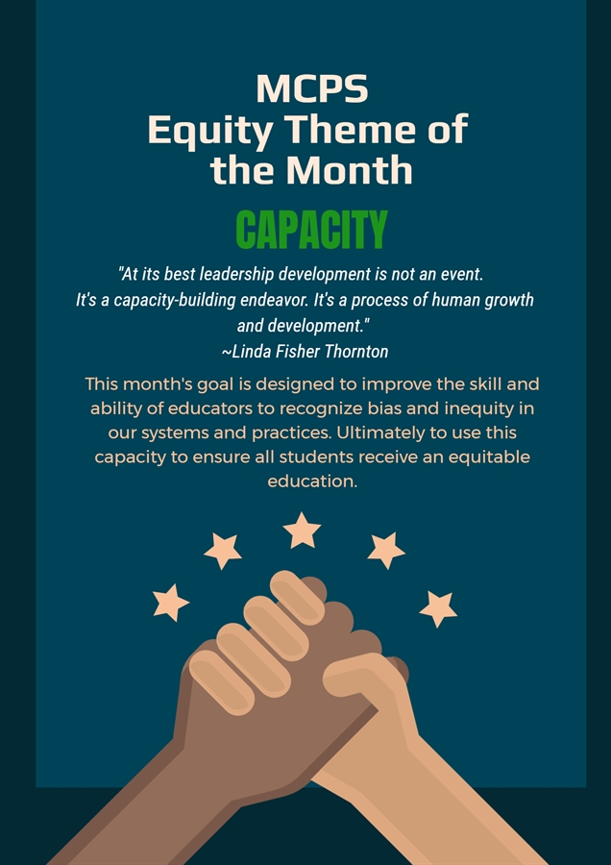

December
Theme: Awareness
Purpose: to be aware of our ability to impact change though understanding the struggle yet the resilience of underrepresented populations with our educational community.
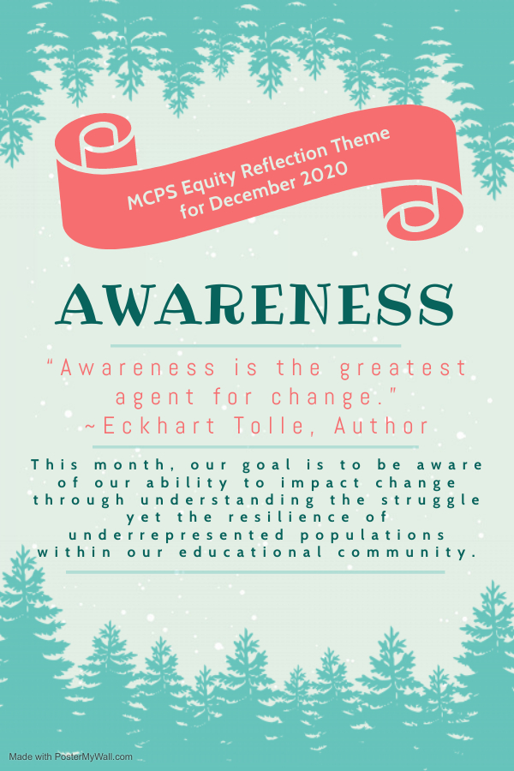
Resource Link: Self-Awareness during the Holiday Season

November
Theme: Opportunity
Purpose: To understand that in an educational setting we have many opportunities to share and gain authentic knowledge about our history.
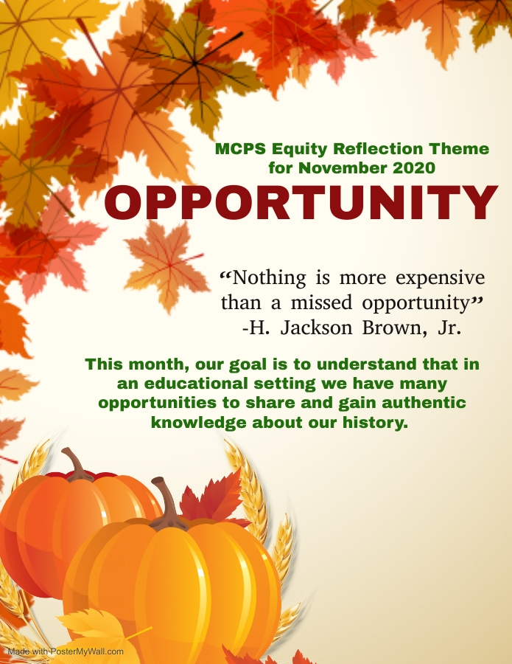

October
Theme : Identity
Purpose : To acknowledge, explore, and accept the difference that exist in learning communities.
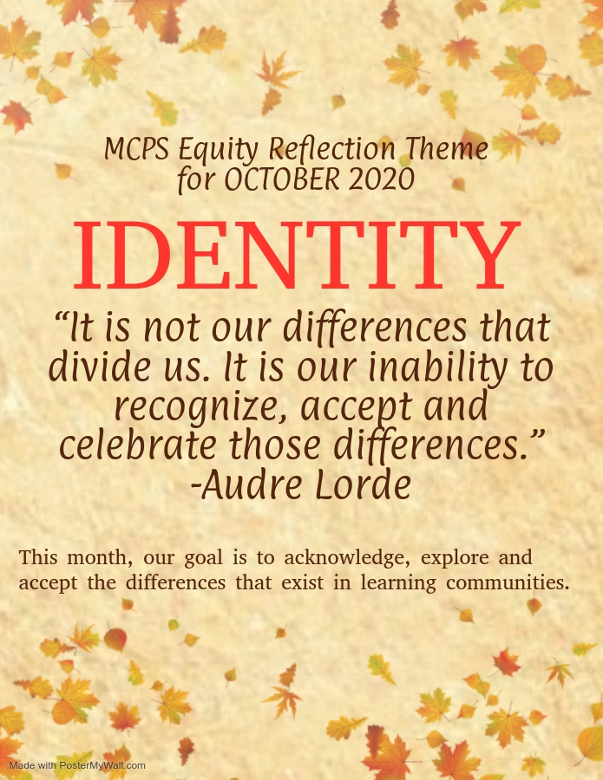
Resource Link : Identity in Education

